**DAILY ONLINE ACTIVITIES SUMMARY**

|  |  |  |  |  |  |  |  |
| --- | --- | --- | --- | --- | --- | --- | --- |
| **Date:** | **28/06/2020** | | | | **Name:** | **Sheetal** | |
| **Sem & Sec** | **8 B** | | | | **USN:** | **4AL16CS091** | |
| **Online Test Summary** | | | | | | | |
| **Subject** | | **-** | | | | | |
| **Max. Marks** | | **-** | | **Score** | | **-** | |
| **Certification Course Summary** | | | | | | | |
| **Course** | **Essentials of Data science** | | | | | | |
| **Certificate Provider** | | | **Udemy** | **Duration** | | | **2 hr** |
| **Coding Challenges** | | | | | | | |
| **Problem Statement:**  **1) Program to count the number of each vowels** | | | | | | | |
| **Status:completed** | | | | | | | |
| **Uploaded the report in Github** | | | | **Yes** | | | |
| **If yes Repository name** | | | | [alvas-education-foundation](https://github.com/alvas-education-foundation)/ **[sheetal-shettigar](https://github.com/alvas-education-foundation/sheetal-shettigar)** | | | |
| **Uploaded the report in slack** | | | | **Yes** | | | |

ONLINE TEST

**CERTIFICATION**

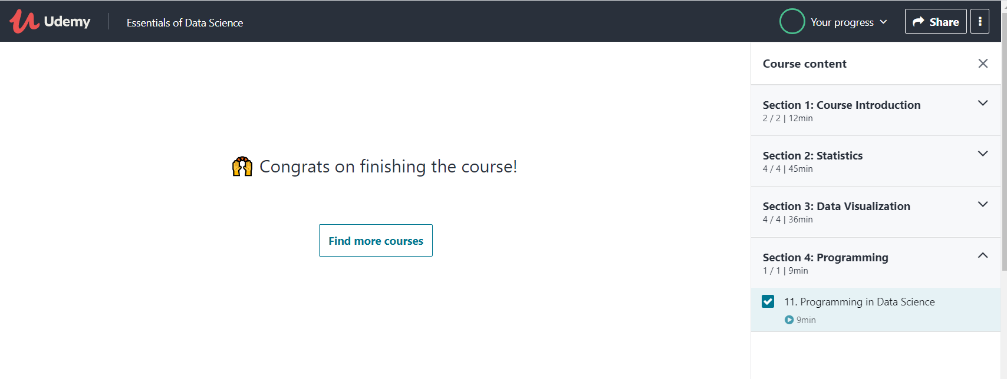

CODING CHALLENGE:

PROGRAM 1 :

1)

vowels = 'aeiou'

ip_str = 'Hello, have you tried our tutorial section yet?'

ip_str = ip_str.casefold()

count = {}.fromkeys(vowels,0)

for char in ip_str:

if char in count:

count[char] += 1

print(count)